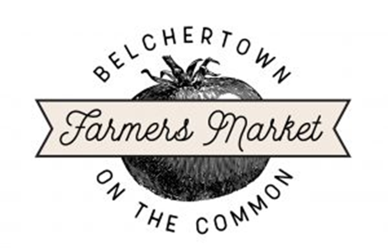
2023 Sponsorship Opportunities for the Belchertown Market

Why Sponsorship?
The Belchertown Farmers and Artisans Market runs Sundays from June 11th through October 1st on the Belchertown Common. Like many events, the market incurs operating expenses such as liability insurance and advertising for example. As we work to grow our market and reach further into our community, sponsorship funds are essential for promoting and sustaining local vendors who participate, including small farms, local artisans and entrepreneurs. Hundreds of community members have come to rely on the fresh, local products that our vendors work hard to supply each week.

Sponsorship Levels
$50 level – “Sprout” – Your name/business name listed on ‘thank you’ sign at entrance to market.
$150 level – “Root” – your name/business name listed on ‘thank you” sign and on website.
$250 level – “Shoot towards the Sun” – your name/business name listed on ‘thank you’ sign, on website, and feature on Facebook/Instagram pages.
$450 level – “Harvest” – your name/business name listed on ‘thank you’ sign, on website, feature on Facebook/Instagram pages, and Sponsor Day where you will be featured at entrance to market/or can have a table to promote your business.
$______ In-Kind Donations in any amount.

It’s easy to sign up for your Sponsorship!
Simply send your check, payable to Belchertown Farmers Market” to:
Belchertown Farmers Market, P.O. Box 524, Belchertown MA 01007
Please write “BFM 2022 Sponsorship” in Memo Line

Please contact us with any questions; thank you for your consideration!
Joyce Douthwright, Market Board President
Email: coldspringsoapery@gmail.com

